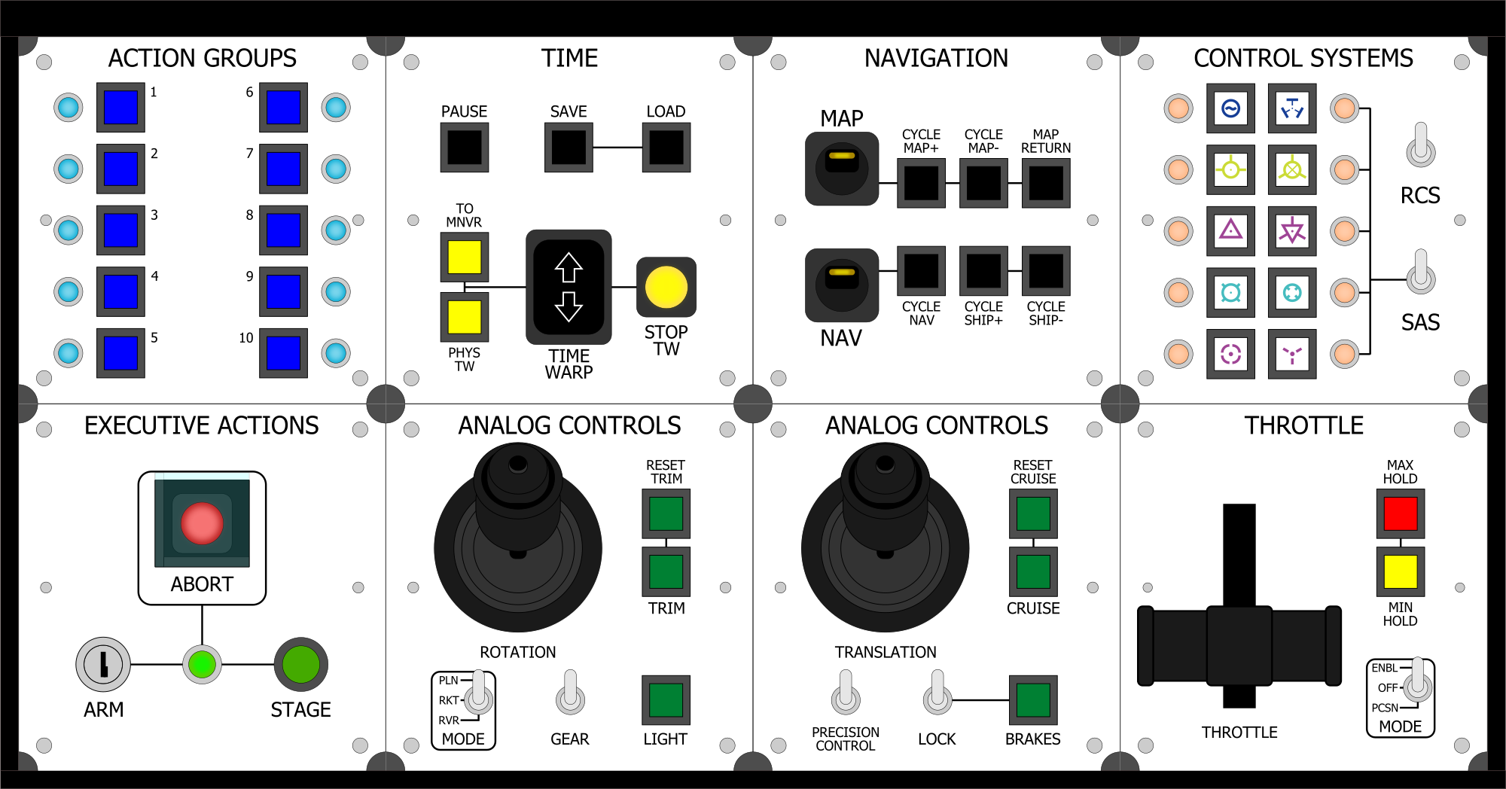

Untitled Space Craft

Complete Documentation

